Itchy, hot spots, general allergic type reactions?

Try this…. All steps, not just one or two. The premise is that we do not know exactly which of the ones below will help but in concert with each one, you are bound to hit the cause and healing combination. Good luck… remember, I AM NOT A VET!!! Christy

- Good bath. Rinse with 1/3 vinegar plus 2/3 water combination. This changes the PH of the skin and takes care of any yeasty problem. Leave on the skin.
Then take a bucket of warm water, add a spoonful of flea dip (not powder or such…true flea dip). Pour over dog and leave on. Can pat dry.
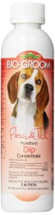
Amazon.com has several available. Here is one: Bio Groom Flea and Tick Dip.

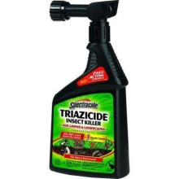
- Spray the yard with Triazicide. You connect to the garden hose and spray last thing at night after dog goes out for the last time. Do not spray if due to rain that night. Let dry on grass before dog goes out again. Home Depot, Lowes, etc.

- Change Foods. Choose something with no soy, no wheat, no corn. Diamond Naturals, Lamb and Rice works well. Looks like Tractor Supply 4 Health is a good one too…trying that myself. Watch the treats too…none of those bad things in them and made in the USA. Use one with a lesser protein (not chicken or beef).

- Give Benedryl for once a day for 30 days. This helps to relieve the itchiness and break the licking cycle.

- Spray the hot spots or redness areas with spray deodorant like Ban. Tastes bad and discourages licking.

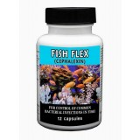
- Give 30 days worth of antiobiotics. I like to order from this site: http://www.fishmoxfishflex.com/index.php/fish-antibiotics.html
I give FishFlex. 500 mg one time a day for 30 days.

- Clean the crate and dog boxes thoroughly. Wash all bedding, etc.

- Bomb the house… with an insect killer product…of course, leave the house and take the dog while you are doing this.

- Do not Use any type of flea control for several weeks. You have put enough poison on the dog with the baths. I do not use flea control unless I have a flea problem…no need to. I do not spray myself once a month with insect repellant…grin. But when I do, it is Nexgard for the dog.

