Grooming Your Springer

Step 1: Bathe and dry your puppy so you are working with a clean coat. This helps your clippers stay sharp. Any type of puppy shampoo will work. Later on, I love the show shampoos which enhance the white to its whitest.
Step 2: The FEET: with a small pair of scissors (I buy mine from Walmart in the sewing section, about $5), run your fingers through each toe (webbed of course) to lift up the hair in between the toes. Cut directly parallel to the skin to cut off all excess hair on each foot. Then turn the foot over and cut off all that excess hair underneath the pad. Do not try to go into the pad corners just what is sticking up with the scissors parallel to the pad. Then with the foot on the table, trim around the outside of the foot so it is nice and cat like...rounded; with no hairs sticking out anywhere. Feet should always be nice and neat. This also gives you less hair to drag in the dirt from the yard...yippee.
STEP 3: THE NAILS: With a Dremel (yup your hardware store type); hold the feet so you are protecting the bottom of the pad and kind of pushing out gently the nail itself. Using the Dremel take those couple of seconds (longer when they are older) and let that sandpaper trim down the nail. Stop when the dog either moves away, withdraws the paw or you reach near the pink inside the nail. This is the blood supply and begins to hurt them at that point. Do each nail. If the dog does not want you to touch the toes, start handling the feet regularly as you watch TV etc. Get them used to you handling the feet (and all other parts of the body like ears, inside the mouth, etc.) If you do this regularly, the quick, (pink part), will begin to recede and you will end up with shorter nails; a good thing. (Regarding the Dremel...I tried a battery operated on once and it did not seem to work as well as the corded model on the adult dogs.)
STEP 4: THE HEAD& NECK: First with your scissors, clip off all of those whiskers for a nice clean look. With a #10 blade on a clipper, begin with the hair at the top of the blaze (which is the white line or space in between the eyes) moving the clipper from the front of the eye area toward the neck line. I usually continue until I meet the collar around the neck and then swoop up to try to blend the clean cut with the uncut hair on the neck and back. Continue in this fashion until you have cleaned out the hair all around the inside of the ears, cheek area and one third 1/3 down the length of the ears from the top down 1/3. This should include the area all around the inside of the ear so that that is all clear of hair and air can help to dry any wet ears. About one clipper swipe on the outside of the ears all around the head and collar should bring you to the neck area underneath the jaw-line.
Holding the head/jaw upwards, take the clippers and in a downward motion, clip underneath the bottom lip down until you reach that little chest bone at the base of the neck. Clip the hair all around the neck line in a circle or ending in a V (underneath the neck) so the underside of the jaw-line and neck are all clipped close. This helps to prevent a yeasty type throat and neck where water drips when they take a drink of water. If you have some gypped up looking places (where it is not smooth or even) take your thinning shears and slip in those areas. That usually helps to smooth or even out any gypped areas where the dog may have moved, etc. That is it for this area.
STEP 5: INSIDE EARS: You should have already clipped all the hair leading into the ear canal with the clippers or a pair of scissors. To clean the ears, use any ear cleaning type product…you can buy these online like www.Jefferspet.com ear cleaning solution. I use little round make up cotton pads and put a little cleaner on the pad and using my index finger wrapped around it, clean the inside of the ear until it comes out clean. That’s it.
STEP 6: TAIL AREA: For cleanliness, I use the clippers to clip all around the tail nub and around the anus area with a quick swipe of the clippers. Hygienically, this helps keep the dog clean. Then around the base of the tail, after I have cut it down and cut any flags on the end which are waving, I use a thinning shears to blend in the cut area with the top coat. All done.
STEP 7: LOWER HOCKS: From the back knee to the bottom of the leg, I take a couple of swipes with the clippers to remove any excess hair on the outside of the leg from the knee down. This helps eliminate dirt brought into the house with this. ONLY on the back two legs.
STEP 8: FRONT LEGS: Comb the feathers out so there are no snags or tangles. Then, using a pair of scissors, just even them up snipping only a few hairs here and there. If they get extremely long, you can shorten them a bit taking the hair in between your fingers to get a straight line. Now comb all of the front hair leg straight down. Take your scissors and cut straight across parallel to the pads of the feet to even the hair to the beginning of the foot pad rear. This should give you a nice angled look…with the angle beginning at the bottom of the foot coming up about an inch and then straightening out going up the leg.
STEP 9: TOP COAT: Using a tool similar to a Mars Coat King, strip the extra dried loose undercoat out on the top and sides of the coat/back. You can also use a stripping knife which is quite tedious to do. But that is how you get those gorgeous show coats shown below.
STEP 10: BELLY H AIR: Gently snip the hair so you have a nice curve underneath the tummy as show in the pictures below. Here is Gibbs as he won BEST IN SHOW at ten months old.
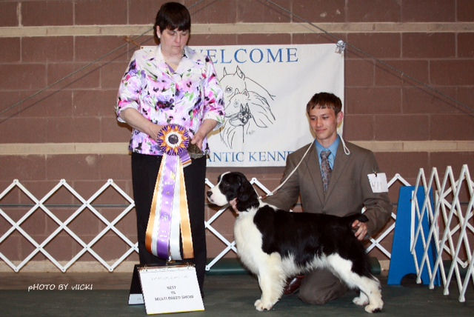
Below is a perfectly groomed Springer. This is Tyra; Gibbs mother.

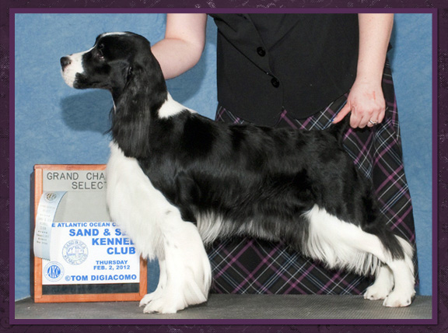
STEP 11: TEETH and GUMS: Do not forget to brush your dogs’ teeth with doggie tooth paste. This is a welcome end to all the trimming and grooming. They will like it, have nice breathe and save you tons of money at the dentist cleaning plaque off of the teeth later on. Good job!
STEP 12: SNUGGLE time. Now it is time to snuggle and love, love, love them!

