SAR Retirement Announcement

C:\Users\Christy\AppData\Local\Microsoft\Windows\Temporary Internet Files\Content.IE5\QVAD2ZER\MC900437946[1].wmfJune 21, 2014

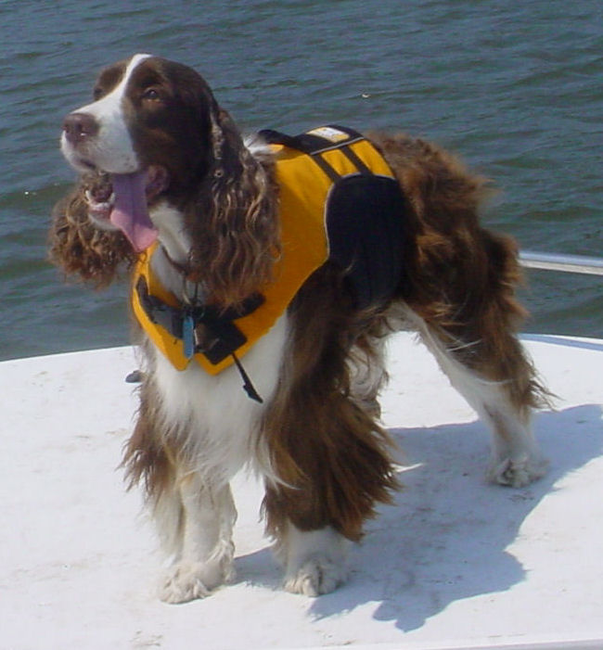“Gypsy Lee …”

Majic Vagabond Heart

Born: October 2, 2003 –

“It is with pride and humility that I tender my official retirement with the Brunswick Search and Rescue Team and the law enforcement agencies in North and South Carolina. I would like to thank all of my team members for the many hours they have put forth in training me. It has been my pleasure and honor to serve our community and state, however, it is now time for me to relax a bit and put away my bell and search collar. I will remember each and every one of my searches all across the Carolina’s and wish each of you the best for all those future searches. I am looking forward to my new role as the public relations expert and companion dog, but especially as the new couch warmer. Thank you to each of you on BSAR and in the law enforcement community for allowing me to be a part of your searches as we looked for lost or missing persons.”

BSAR Love,

Gypsy

Gypsy was certified and has worked tirelessly in the areas of Wilderness Air Scent, Human Remains Detection, and First Responder Dog with her handler, Christy Judah.

She earned her Canine Good Citizen from the American Kennel Club as well as her Wilderness Air Scent Title from the American Kennel Club.

She earned her UKC Championship with several Group Three placements on multiple occasions.

At 10.5 years of service, Gypsy has responded to numerous searches and had multiple finds. Her temperament and service has been confident and an outstanding representative of SAR dogs. Gypsy loves everyone and everyone loves Gypsy.

Some of her more notable searches include:

Tornado rubble response.

Location of multiple grave sites including colonial grave sites over 200 years old within multiple locations in southeastern NC, northeastern NC, and South Carolina.

Location of a murder weapon with blood of the victim still on the weapon.

Location of several suicide victims.

Location of a homicide victim.

Location of disarticulated bones of homicide victim.

Drowning.

She will continue to represent SAR as a public relations representative through her retirement years where she will take it easy and live a well-deserved retirement.

She will continue to serve in the capacity as a public relations representative of search and rescue and as a faithful companion.

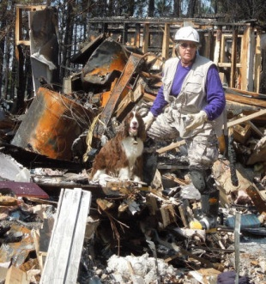 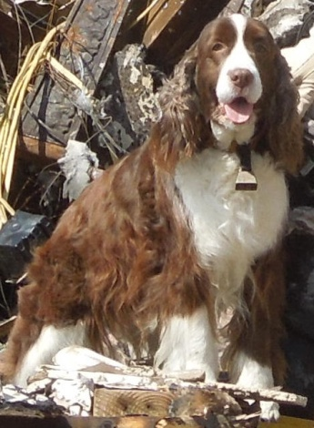 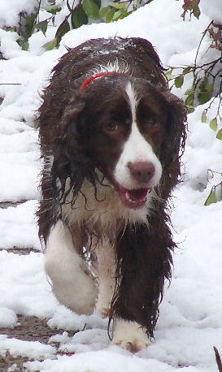

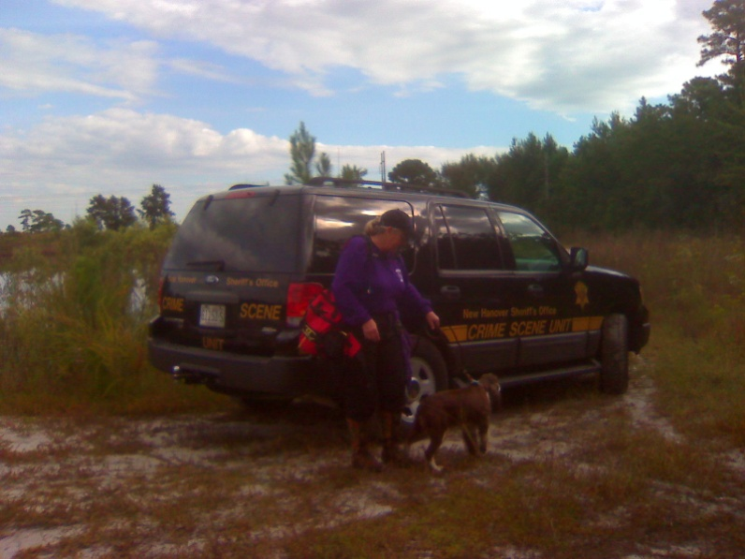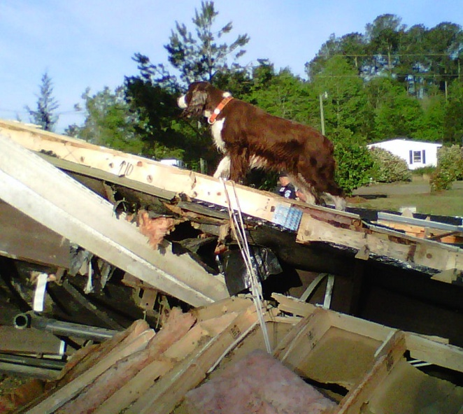

After locating homicide victim. Bladen County tornado rubble.